India tour 14-30 November 2018
Hotels days 4 and 5
Itinerary:-
From the Anglican Tours India tour booklet the hotels listed for the days 4 and 5 are as follows:-
Day 4 – Mandawa, located in the back roads of the desert south west of Delhi. Vivana Culture Hotel in Rajasthan.
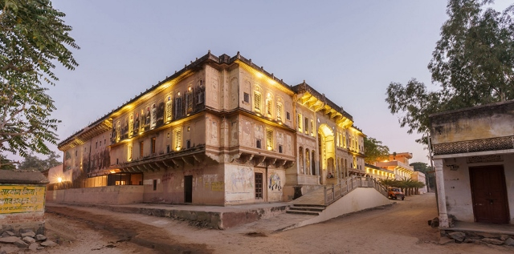
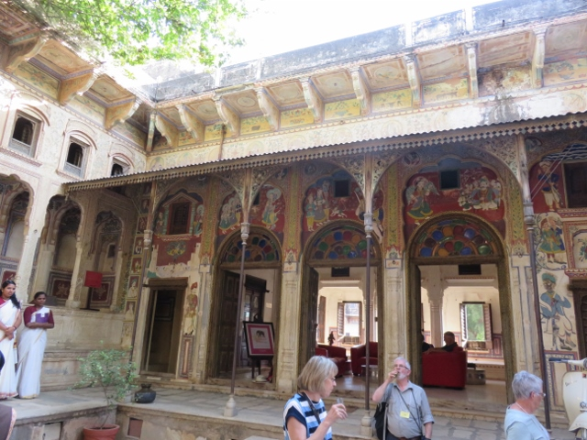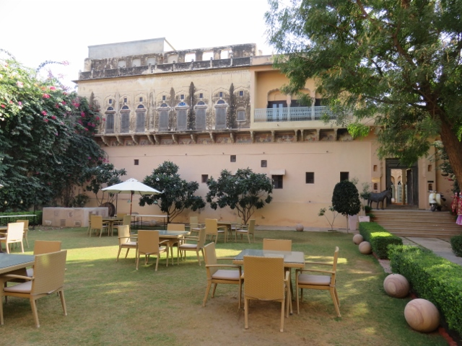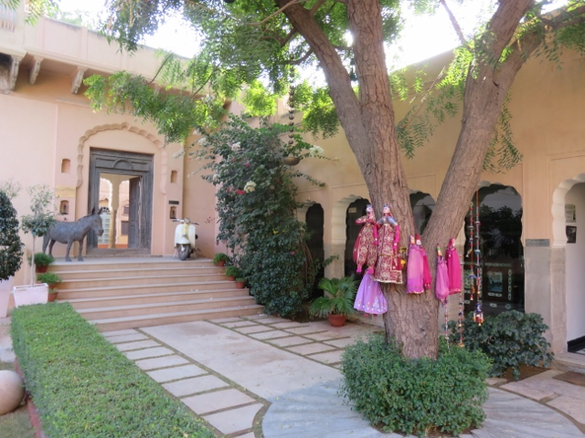
Interior court yard after being showered with rose petals upon arrival and serenaded with a viol & turbaned singer.
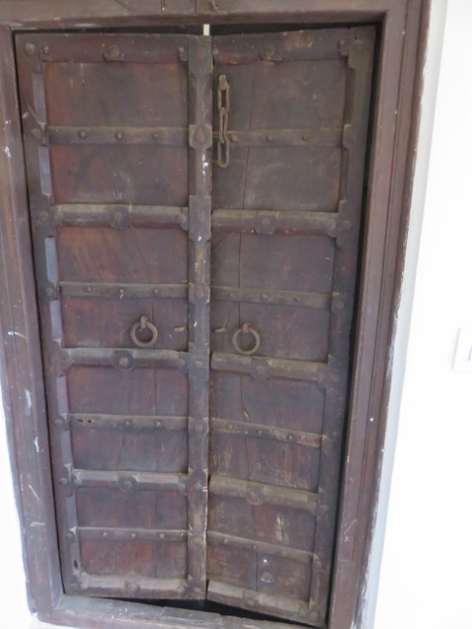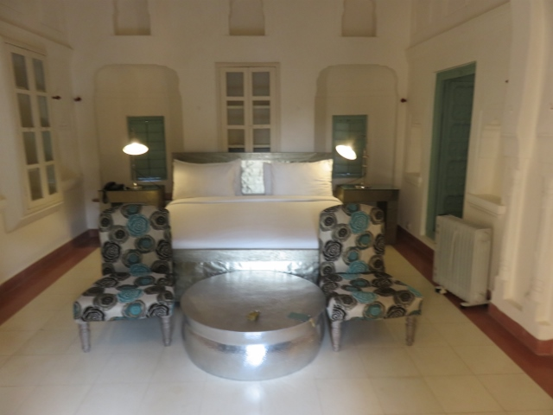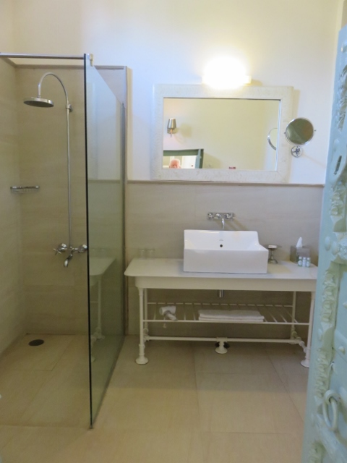
Medieval door to Alan’s room 305. Main bed room with shiny table bathroom through a small door.
Ear plugs supplied as the partying on from neighbours at another tourist spot a few doors away continued late into the night. Dinner was served in the evening in the outdoor courtyard with entertainment supplied by the viol turbaned singer and a female counterpart. Later a puppet show was performed by other entertainers and puppets made for sale to the guests. Cost about 250 rupees or $3OZ.
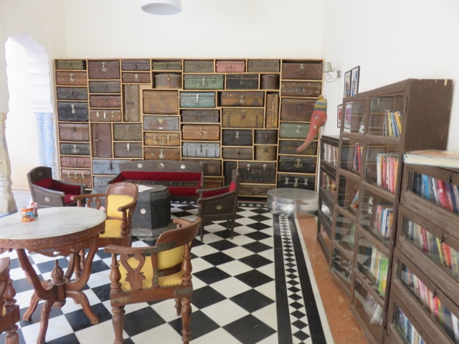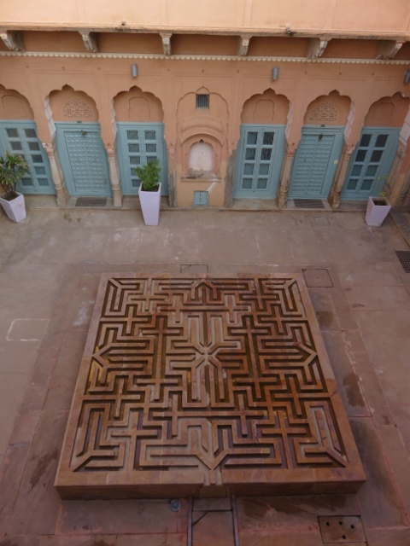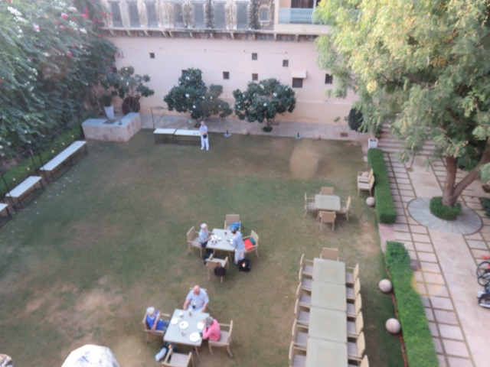
Eclectic collection of books and travel cases. Inner courtyard water feature main courtyard for dining.
……………………………………………………………………………………………………………………………………………………………………………….
Day 5 hotel Sunday 18th November 2018, Bikaner:-
Hotel - Samvit Shikshan Gandhi colony Samta Nagar Bikaner. Still in the semi desert region of Rajasthan.
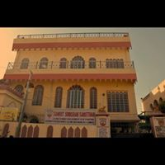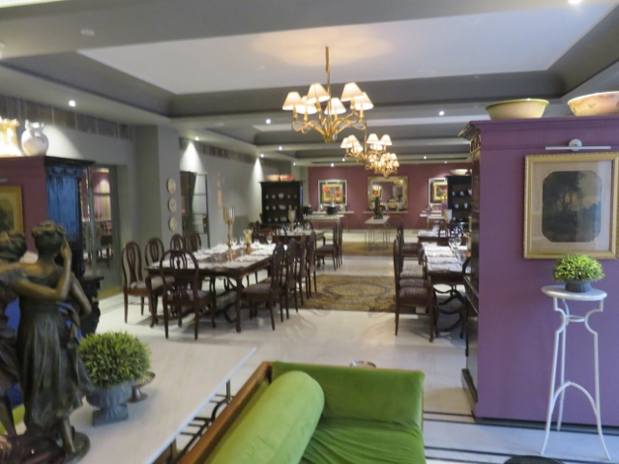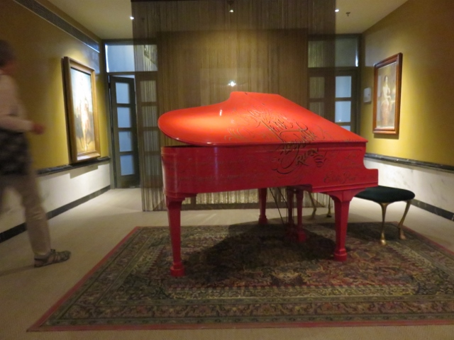
Hotel Samvit Shikshan Reception area + casual dining red piano in reception hall.
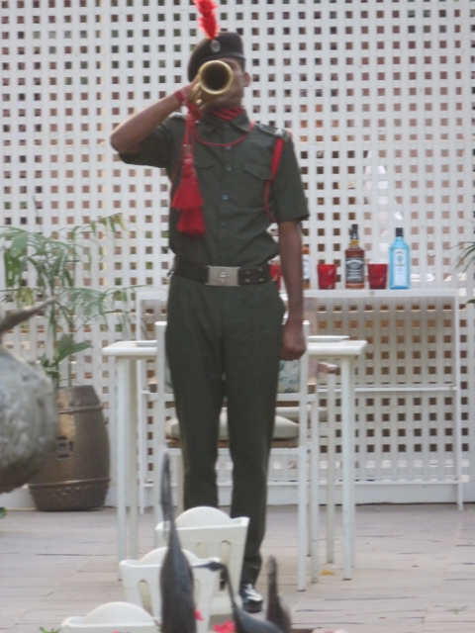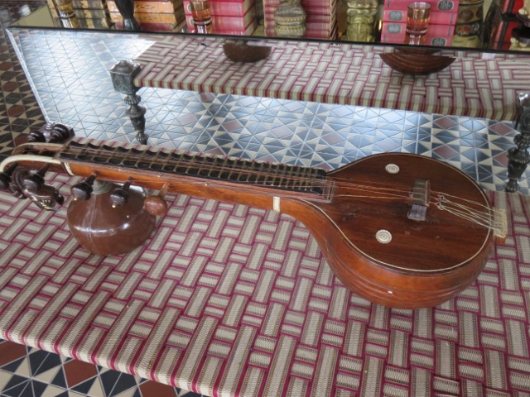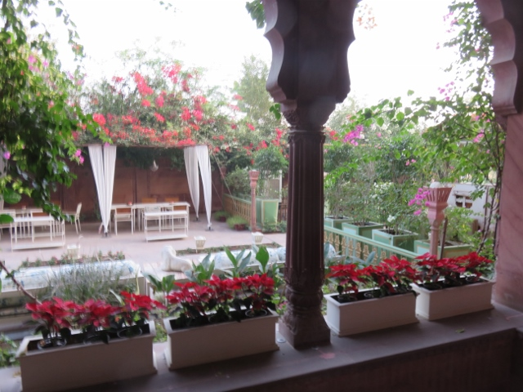
Bugler welcome tune on arrival. Indian stringed instrument on display. View of hotel entrance gardens.
This hotel was a big step up in comfort amenities from the last hotel in Mandawa. The rooms were more modern, larger in size and with more bathroom facilities. Bikaner is a more prosperous and larger town that Mandawa although still in the semi-arid area of Rajasthan. Alan was allocated room 112. The public toilets were something special after the not so salubrious ones of the last hotel. My apologies to readers who might find the photo of the men’s public toilet on the next page unusual!

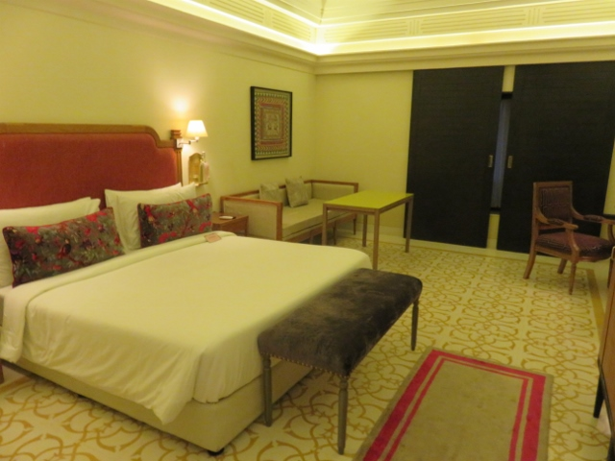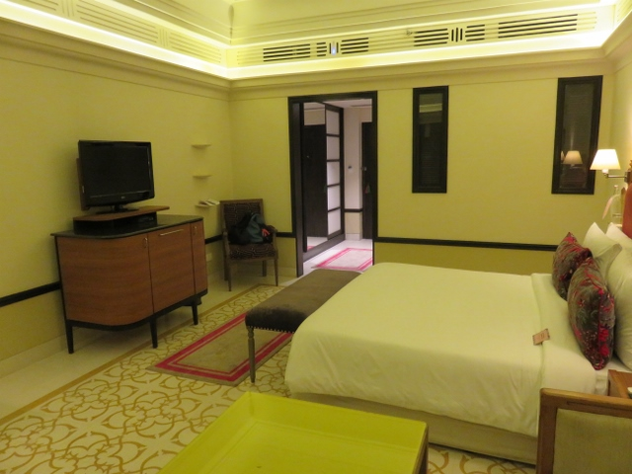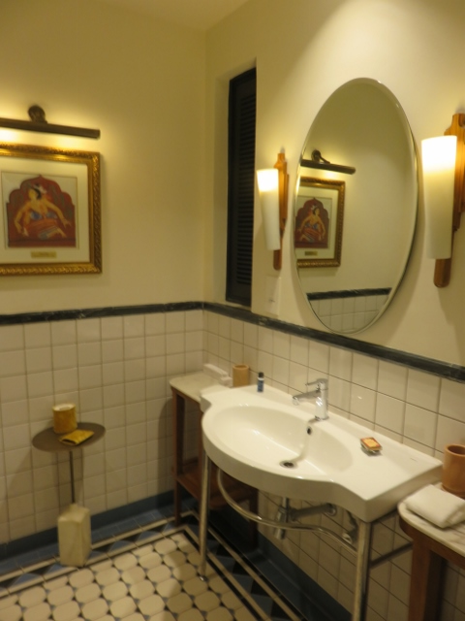
Alan’s room 112 – very big! View towards the entrance of room. The bathroom with large mirror.
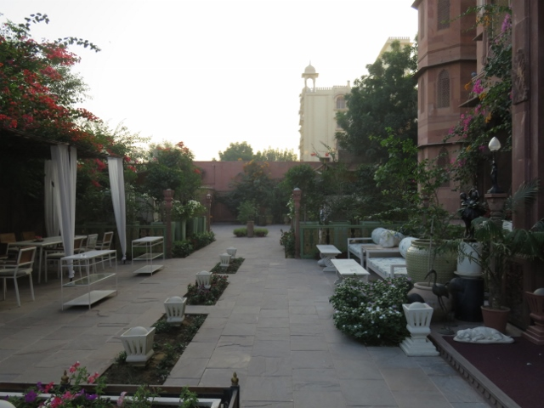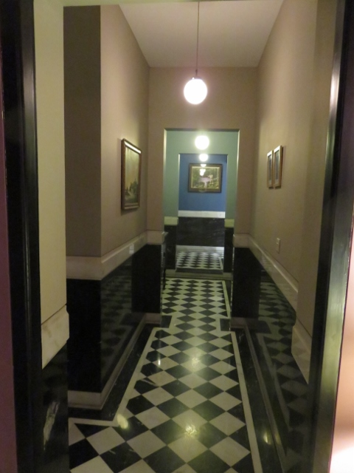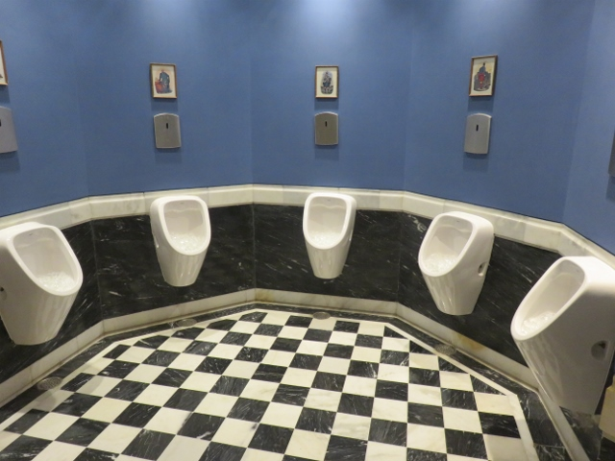
Gardens at hotel entrance. Hallway to toilets. Men’s urinals in semicircle.
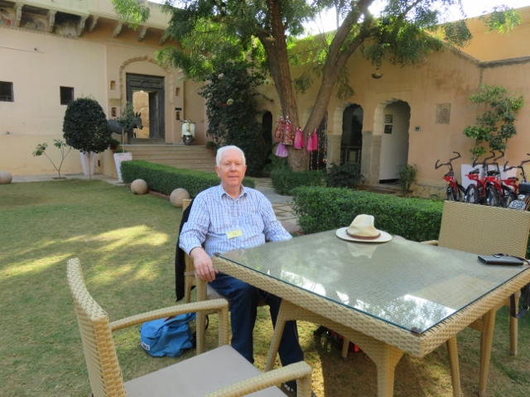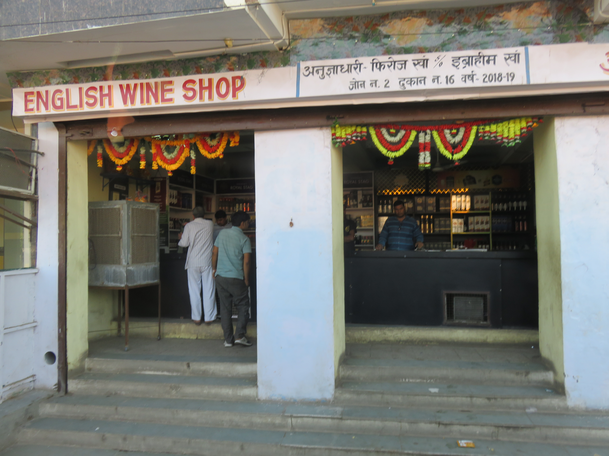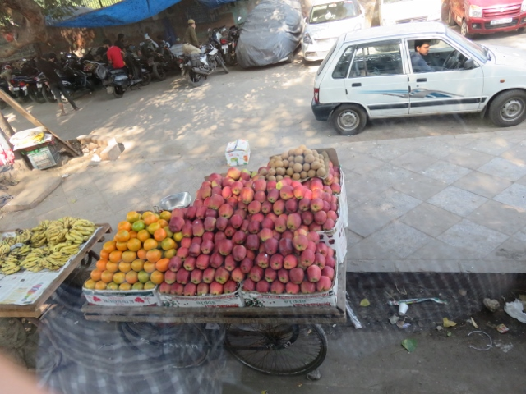
Alan enjoying a rest in courtyard. Wine shop in Bikaner. Fruit barrow pushed along road.

